**GUIDANCE FOR SHORT-TERM REDUCED WORK ZONE SPEED LIMIT REQUESTS**

A short term work zone speed limit may be requested where:

The Work Zone duration is 72 hours or less on an Interstate or other limited access, multi-lane, divided highway and has a posted speed limit of 55 MPH or greater.

Reduced speed limits for work zones not meeting the above conditions may be requested via TE-350.

RECOMMENDATIONS FOR WORK ZONE SPEED LIMIT:

1. The maximum reduction of the regulatory, posted speed limit is 10 mph.
2. The minimum work zone speed limit to be posted is 50 mph; exceptions can be made by RTE.
3. Signs indicating the reduced work zone speed limit must be posted in accordance with the Virginia Work Area Protection manual.
4. A request for enforcement of the reduced work zone speed limit should be made to the appropriate Virginia State Police office.

CONDITIONS WHERE A REDUCED WORK ZONE SPEED LIMIT MAY BE WARRANTED:

1. A lane closure resulting in congestion that is expected to reduce vehicle operating speeds by at least 10 mph for the majority of the time the work zone is in place OR;
2. Pavement surface conditions such as uneven, ridged or broken pavement or potholes that produce vehicle instability for the majority of the work zone OR;
3. Workers within 2 feet of a travel lane for the majority of the time the work zone is in place OR;
4. Lane width reductions resulting in travel lane widths of less than 11 feet for the majority of the work zone OR;
5. Work activity that reduces sight distance available to motorists below that required at the original posted speed limit for the majority of the time the work zone is in place.

Based on the significance of these conditions a reduction of the speed limit up to a maximum of 10 mph may be requested.

NOTE: During those times of day or along sections of the work zone where the above conditions are not prevalent, a reduced work zone speed limit shall not be posted and any signs indicating a reduced speed limit shall be covered or removed.

Traffic Control Devices shall be designed and installed based on the original posted speed limit.

In addition, the Contractor shall be responsible for the following:

1. Installing/removing new speed limit signs and covering/uncovering all signs indicating the original speed limit throughout the period the work zone is in place AND;
2. Maintaining records of the date, time, and termini for all speed limit reductions posted in the work zone, subject to periodic inspection and FOIA requests.

**SHORT-TERM REDUCED WORK ZONE SPEED LIMIT REQUEST FORM**

In accordance with the stipulations and conditions indicated on Page 1, a reduction of the regulatory, posted speed limit is requested to establish a work zone to complete the work described below:

**Describe the nature of the work to be completed**

At the following location(s):

**Indicate Interstate and From/To Mile Marker or Route/Road Name and From/To location**

For the work zone established at the dates and times indicated below:

Indicate date(s) of work including start/end times i.e. Nov 11 – 13, 2014 from 7 p.m. to 4 a.m. AND Dec 14, 2014 -9 p.m. to 6 a.m. etc.

The nature of the work creates the conditions indicated below in accordance with the conditions detailed on Page 1:

**Describe the nature of the work to be completed in accordance with the conditions as described on Page 1**

The (original) Posted Speed Limit is: **Indicate the posted (original) speed limit** **mph**

The Reduced (Work Zone) Speed Limit Requested: **Indicate the reduced (work zone) speed limit being requested** **mph**

I understand that the requested work zones shall conform to the stipulations and conditions described on Page 1 and further, that when the conditions for which the reduced work zone speed limit is requested are not prevalent, any signs indicating the reduced speed limit shall be covered or removed.

The contractor shall be responsible for maintaining records of the date, time, and termini for all speed limit reductions posted in the work zone, subject to periodic inspection and FOIA requests.

Requested By: Indicate the Agency or Firm making the request

Indicate the Name and Title of the Requestor and the office location

Signature of Requestor: ______________________________________________________________________

In agreement with the conditions prescribed in VDOT’s “Work Zone Speed Limit Study,”

Choose an item. the proposed work zone speed limit reduction.

__________________________________________________________ ______________________________

Regional Traffic Engineer Date

**Insert Regional Traffic Engineer comments**

**Typical Traffic Control**

## Signing for Speed Limit and Fine Signs in Work Zones

(Figure TTC-52.1)

NOTES

**Standard:**

1. **Prior to the implementation of this Typical Traffic Control layout, the Regional Traffic Engineer must approve a speed reduction**1 **in a work zone after performing and evaluating1 a Traffic Engineering investigation**1 **per Traffic Engineering Division Memorandum TE-350.**

Option:

1. This layout depicts signing requirements for speed limits and increased fines in work zones. Additional signing and traffic control devices may be required based on the operation being performed.

Guidance:

1. Sign spacing distance should be 1300'-1500' for Limited Access highways, and on all other roadways 500'-800' where the posted speed limit is greater than 45 mph, and 350'-500' where the posted speed limit is 45 mph or less.

**Standard:**

1. **On divided highways having a median wider than 8', right and left sign assemblies shall be required.**
2. **The use of the WORK ZONE $500 MAX FOR EXCEEDING SPEED LIMIT WHEN FLASHING (R2-V1) 1 sign shall be approved by the Regional Traffic Engineer prior to installation. Type B warning lights shall be installed above the R2-V1 sign and controlled remotely with activation only when workers are present in the work zone.1 If the R2-V1 sign is used the WORK ZONE (G20-5ap) plaque shall be installed above the speed limit (R2-1) sign and the1 FINES HIGHER (R2-6P) plaque below.**

Option:

1. For Secondary and Minor Primary road systems, a 66" x 42" R2-V11 sign may be used.

**Standard:**

1. **If the entire project is signed for a reduced speed, and an original speed limit sign is not within 1000 feet of the END ROAD WORK (G20-2 (V)) sign, signs depicting the original speed limit shall be erected 500'± past the END ROAD WORK sign. On secondary roads without posted speed limits, an END WORK ZONE SPEED LIMIT (R2-12) sign shall be used in place of erecting an R2-1 sign. If only part of the project is signed for a reduced speed, then the original speed limit shall be posted 500'± past the work area.**

Option:

1. Experience has shown that compliance to the reduced speed signing is greater if these signs are placed as close to the work as possible, as opposed to placement prior to the advance warning signs (ROAD WORK AHEAD, etc.).

**Standard:**

1. **The Reduced Speed Limit Ahead (W3-5) graphic signs are only required if the speed limit is being reduced in the work zone.**

Option:

1. During short-term (less than 72 hours) operations, if the speed limit is reduced, the Reduced Speed Limit Ahead graphic signs and the SPEED LIMIT signs may be mounted on a temporary (portable) sign support. The use of the WORK ZONE sign is not required.1

*Guidance:*

*11 The speed limit should be stepped down in advance of the location requiring the lowest speed in ten-mile per hour increments. Additional TTC warning devices should be used.*

**1: Revision 1 – 4/1/2015**

**Signing for Speed Limit and Fine Signs in Work Zones**

### (Figure TTC-52.1)

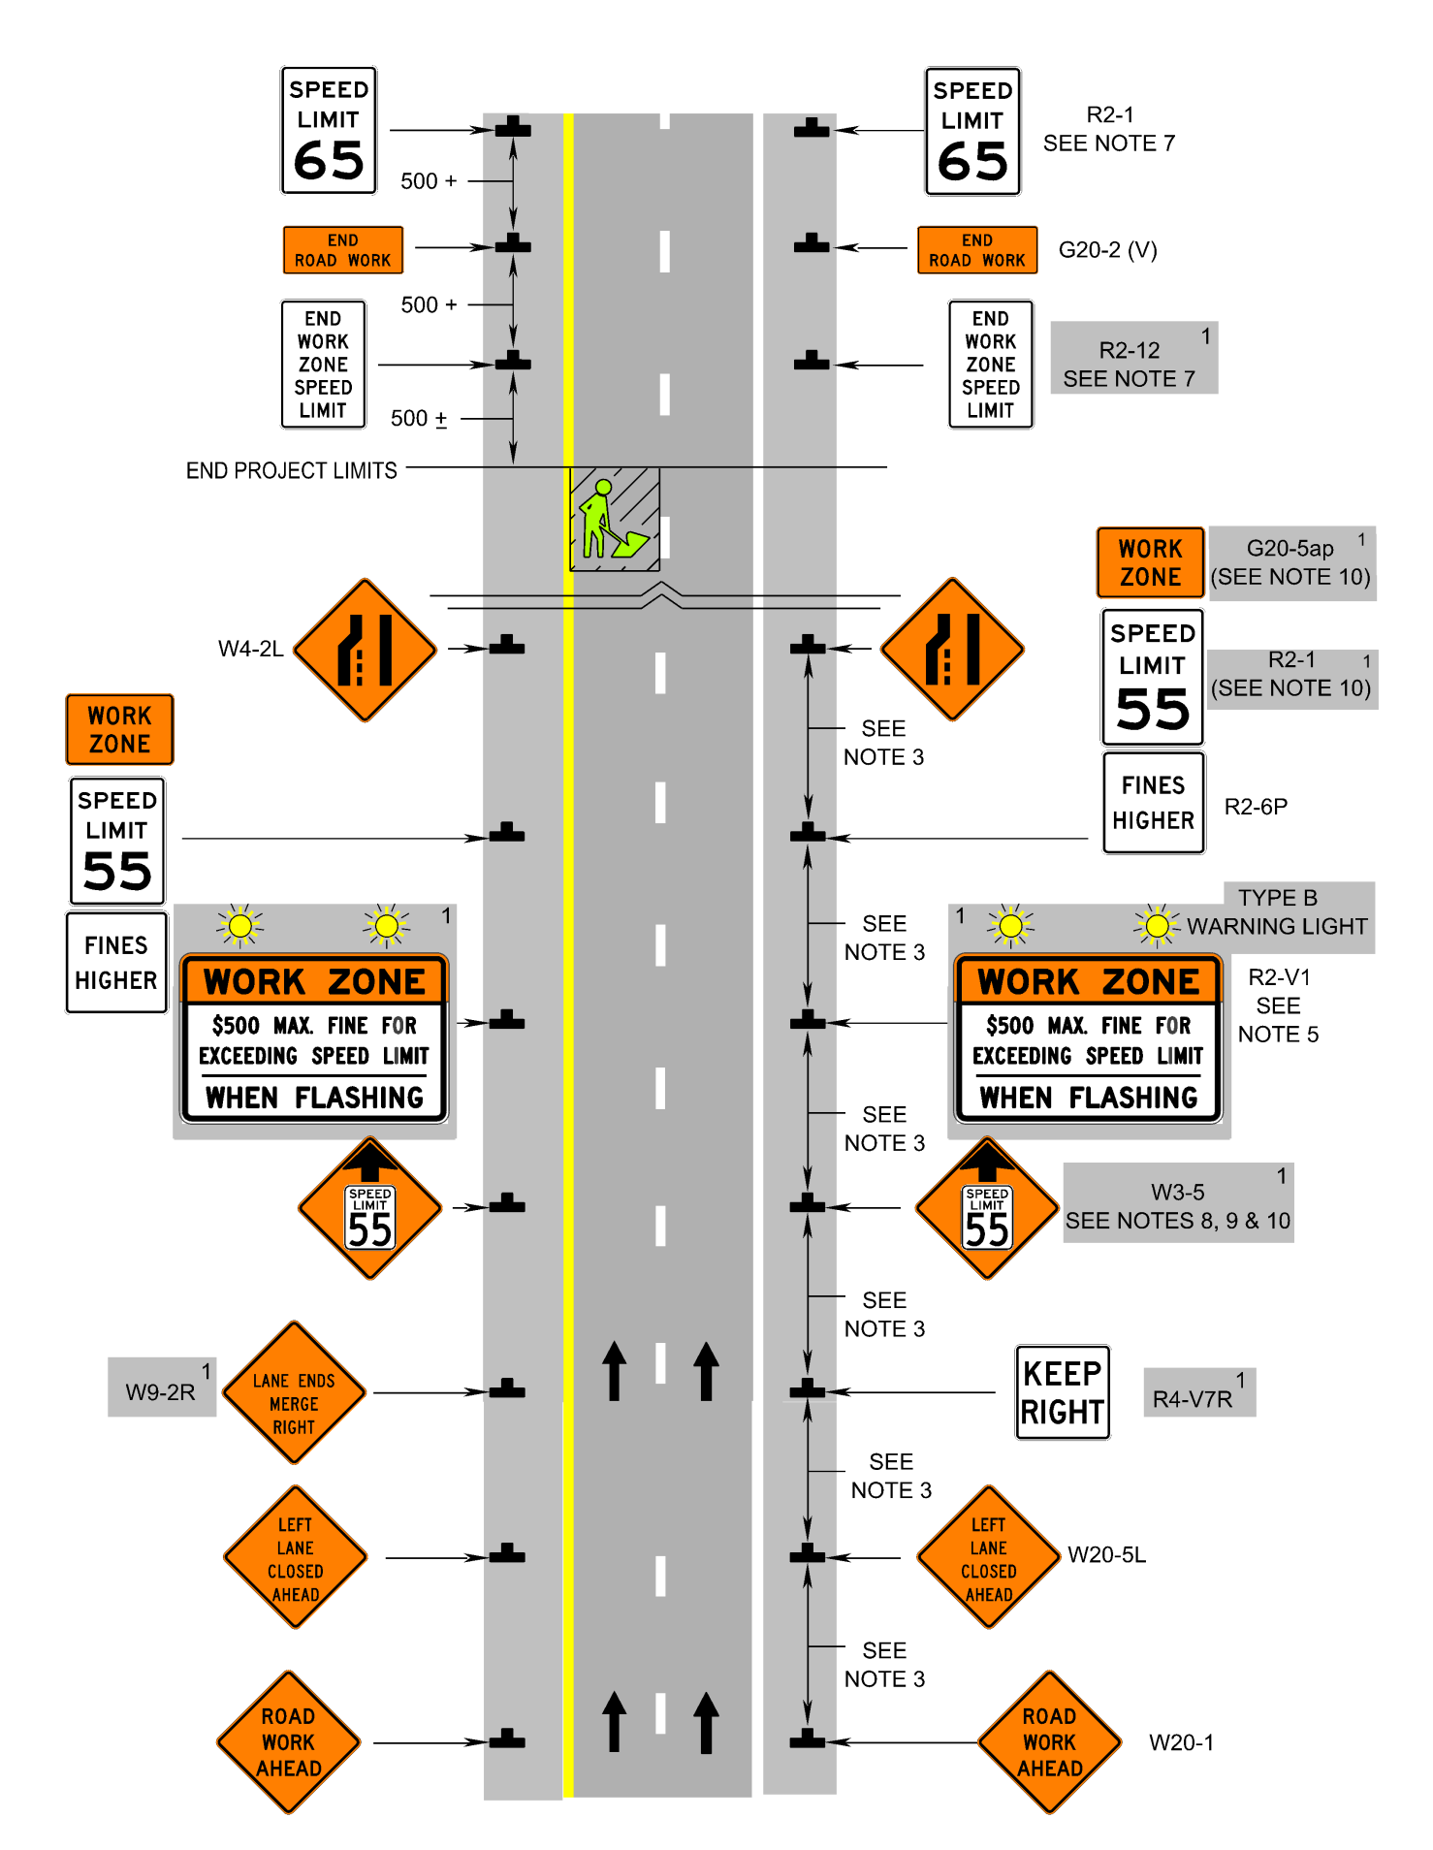

**1: Revision 1 - 4/1/2015**